**Project Proposal**

by

Dhruvil Panchal

Cleveland State University

Date: 10/22/2022

Contents

I. Needs Assessment: 1

II. Identify Stakeholders 4

III. Eliciting Requirements: 8

IV. Possible Solution 11

V. Value 11

1. Needs Assessment:

Our primary goal with this project is to enhance the employees' motivation and reduce stress level, which will also increase their productivity. Additionally, we require a technology platform that offers management programs to an organization's staff. So that workers can maintain a balance between their personal and professional lives.

* + - 1. Problem Statement

A company's financial line may be impacted by the negative effects of stressed employees' health and performance. Employee stress can result in both short-term and long-term issues, both of which have the potential to bring about the failure of a company if they are not handled. Employees who feel they are not being paid properly or who perceive an absence of respect from their coworkers or bosses may experience work-related stress.

Stress might be brought on by too many regulations or a lack of opportunities for progress. Understaffing or managers that send emails on the weekends and at odd hours might result in more responsibilities and less free time for workers to rest. Personal problems that arise outside of work can also cause stress in employees. If clients decide not to visit your business as a result of ongoing exposure to the negative effects of staff stress, your company may experience a loss in revenue. So indirectly organizations are suffering from a lack of productivity, failure, and systematic work as well as employees' low motivation.

* + - 1. Root Cause Analysis.

1. There are many reasons for anxiety in people, and in this day and age, it is very frequent. Everyone experiences stress, which makes it difficult for them to concentrate on their objectives. Numerous factors contribute to the downfall of businesses, but one of them is stress.

Physical analysis

Due to faulty equipment, lack of resources, and outdated technology.

Human analysis

Insufficient abilities or expertise, miscommunication, lack of appreciation and motivation, personality, insufficient sleep, unsuitable roles, Insufficient nutrition, procrastinating work, and irrelevant operation.

Social impact

Culture, marital status, community involvement, and Family issues.

Organizational analysis

Inappropriate selection of approach, unclear instructions, bad facilities, and work environment.

Economical issues

Financial compensation, source of income, employment.

Mental impairment

Autonomic, temperature, respiratory, injury, age, and sensory evaluation.

* + 1. Fishbowl Diagram

1. Change Strategy

i. Current State:

Corporate organizational stakeholders identified that the company’s production is decreasing caused of an unbalanced management structure, lack of resources, and demotivated staff. So the client company's requirement is to reconstruct the management system and to decrease the stress of employees.There are many internal and external factors came up which are affecting employees’ stress levels and productivity such as employees’ personal issues, impossible tasks, no cooperation, facilities, and rewards.

Based on the current state of the organization it may be to most suitable time to provide a new management system and training in order to get a less stressful environment for the employees. As the organization is not getting beneficial results from employees so the new system has to implement. In order to implement a new management system major costs and investments are required as per the stakeholder’s requirements.

1. Future State:

The future state is to implement a new management system which requires more IT solutions. In this case, strict deadlines must follow which allows organizations to complete this process in the expected timeline. The solution would be based on the current business need of the organization. However, it needs to be cost-effective, this could be considered an aligned change strategy.

1. Identify Stakeholders
   * 1. Stakeholders

* Steering Committee(Manager)
* IT Department
* Sponsors
* Project Manager
* Resource Manager
* Executives
* Company Owners
* Analysis Team
* Organizational Client
* Finance Team
* Human Resources(HR)
* Operation Team
* Marketing Team
* Specialists (For Training)
* Team Members
* Senior Management
* Government
* Help Desk
* System Admin
  + 1. **Stakeholder Power/Interest Grid**
* Green indicates supporters, Red for critic and Yellow for neutral stakeholders.

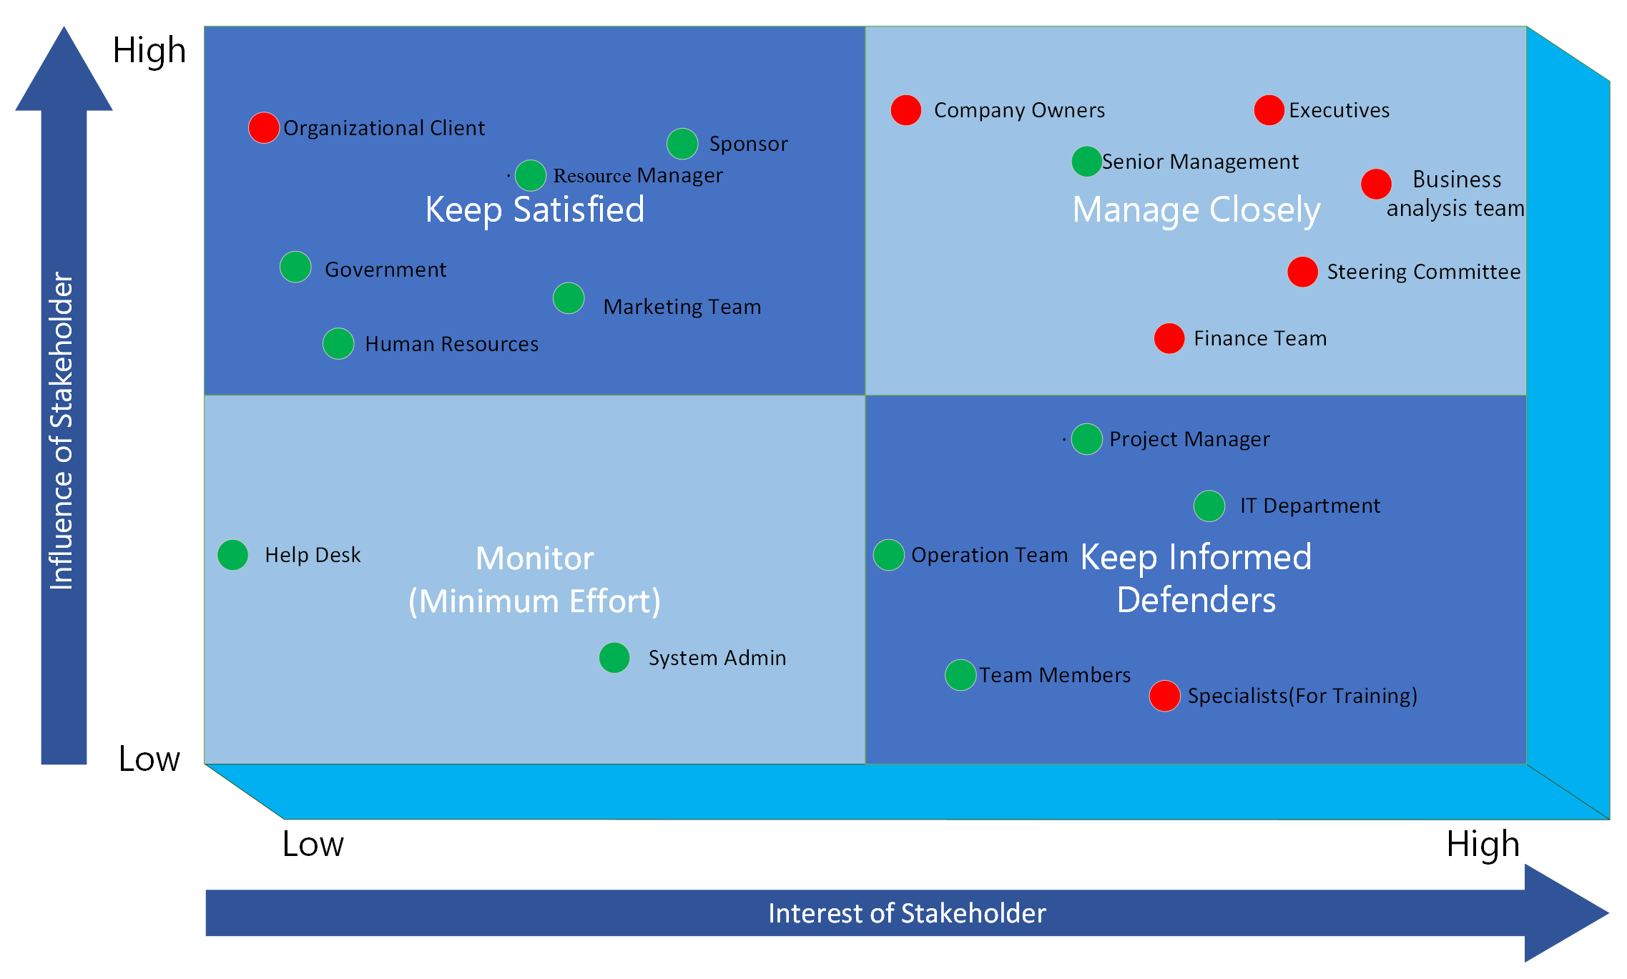

* **Sponsor:** Sponsors are high power, low interest stakeholder because we need to keep them fully connected, and high effort is required to keep them satisfied because they are handling finance management.
* **Steering Committee:** Managers are high power, high interest stakeholder because they are authorized to approve ideas for implementation.
* **Business Analysis Team:** Analysis team is high power and high interest because the analyst team is a bridge between the operation department and IT department and is responsible to create a business plan and give solutions.
* **IT Department:** It has low power but the IT team is high interest because they are responsible to develop and execute the project.
* **Organizational client:** They are high power, low interest stakeholders because regular customers’ satisfaction is our first priority.
* **Project Manager:** Low power but the project manager is a high-interest stakeholder because they are responsible to lead and complete the project on time.
* **Resource Manager:** They are high-power, low-interest people because resource managers will take care of required resources.
* **Human Resources:** They are high-power, low-interest people because HR will responsible for finding, hiring, training, and supporting new employees.
* **Executives:** Executives are high-power, high-interest people because an executive directs, plans, and coordinates operational activities for their organization
* **Company Owners:** Owners are high-power and high-interest stakeholders because they own the whole company.
* **Finance Team:** Finance team has the authority to pass finance-related approval requests so they have high power and high interest.
* **Operation Team:** They manage a diverse workforce in the organization to make sure that the organizational operations are efficient so this team is low power, and high interest.
* **Marketing Team:** The Marketing Department plays a vital role in promoting the business and mission of an organization so they are in high power and low-interest grid.
* **Specialists (For Training):** Specialists will train the employees of the organizational client so they are in high interest, low power grid.
* **Team Members:** They have to do all tasks given by the team leader or management diligently, on time, and to the highest quality. So they are low-power and high-interest people.
* **Senior Management:** They are high-power and high-interest stakeholders because senior managers organize and oversee a team of people inside a company or division. A senior manager's responsibility is to oversee those people to guarantee smooth business operations and that each person performs to corporate and industry standards.
* **Government:** Government is an important external stakeholder in a business because the company needs to take permission and pay taxes to them. So the government is in high power and low-interest grid.
* **Help Desk:** Identifies issues, does research to find solutions, and guides customers through the necessary remedial actions to provide answers to the clients. So they are in low power, low-interest grid.
* **System Admin:** This stakeholder is in low power and low-interest grid. The task of installing, maintaining, and modernizing a business's technical systems falls to a system administrator.

1. Eliciting Requirements:
   1. **Interviews:**

In this case, the stakeholders are as followed: The Business Analyst (Interviewer) and Organizational Client(Interviewee).

1. A combination of structured and unstructured interview:

* What is your company’s mission?
* What kind of services your company is providing?
* What is your role in this organization? How long have you been a part of this organization?
* What is your current market value?
* What makes your work environment different than other organizations?
* How often do you feel stressed at your work?
* Do you think you have enough numbers of employees?
* How do you think that we can improve your employees’ efficiency?
* How often do you provide training to your employees?

1. Interview Guide
2. Goal: The purpose of this interview is to gather fundamental data about your business and workplace.
3. Questions

* What is your current number of employees?
* What do you think are the key factors that affect the productivity level of employees?
* What is your view to increase the productivity level of employees?
* What kind of benefits does your company provide to employees?
* What is your view on technological resources that are provided by your company?

1. Logistics

* The interview will be in-person and scheduled at the client’s office as per the shared availability.
* The interview will be recorded and it may require the use of a scribe.
* Predefined questions have already been sent to the interviewees in order to collect information about the client’s company.

1. Interview Flow

* The purpose of conducting this interview will be to identify current organizational problems including the interviewee’s opinion to propose a desirable solution.

1. Interview Follow-up

* We learned from your interview that there isn’t enough staff at your organization, which may be the major cause of the stress. The information about your firm in the report that follows is based on an interview.

**b. Document Analysis:**

1. Possible Solution
   1. Solution 1: Develop an online platform to provide training on transformation to the employees of client organizations
   2. Solution 2: Specialists will be involved in client organization to fix the current system and maintain workflow and also specialists will deliver knowledge of management to the employee and motivate them.
   3. Solution 3: Develop an application as well to track their activities and detect problems after training.
2. Value
   1. Expected Benefits

* Systematic workflow
* Increased productivity
* Improved employees’ management skills and social life
* Improved working pattern
* Decreased project failure risk.
  1. Expected Costs
* Timeline
* IT support
* Consulting
* Physical resources
* Information resources
* Design
* Installation
* Maintenance
* Operational
* Application Subscription